**Name: Merielle Ann A. Gamboa 11- HUMSS ROMANS**

**Activity: Community Role Map Oct. 27, 2025**

**We Belong: Mapping the Institutions Around Us**

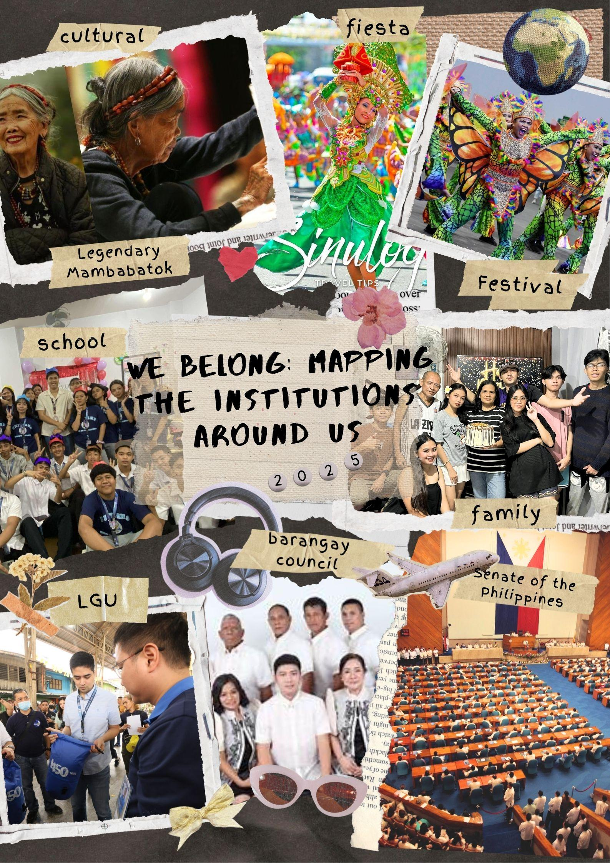

I have learned that cultural, social and political institutions play a big role in maintaining order, identity, alliance, within a society. Cultural institutions like churches, museums, fiesta, festival, and others, teach us the values, beliefs, traditions, and moral that shape the character of individuals. Social institutions such as family , school, community organizations, etc. Are the ones who educate us for learning, support and nourish the people. On the other hand political institutions are the system and organization including LGU's, Courts, CSC, DILG , etc. These political institutions are the ones who are responsible for maintaining the order of society, protect the laws, ensuring the peace and justice in society. The government should prioritize protecting and addressing the issues and problems that our country is facing.Without these institutions there will be no sense of unity in the society, but with these institutions, they serve as the foundation of society through an organized and balanced system. As I reflect, there are things that we should value, those institutions be working to ensure that the society remains organized, peaceful and thriving. This helped me realize that these institutions are more than simply structures, they are guides that shape our lives and strengthen our society.